MINE ENVIRONMENT
MONITORING ROVER
An IoT-based rover for gas detection, obstacle avoidance and live monitoring

Detail | Information
Submitted by | Snigdha Kanakam (2505A21024)  Pranith Billa (2505A21025)  Imran Mohammad (2505A21026)  Vivek Korivi (2505A21027)  Tharun Bioroju (2505A21028)  Hemanth Marri (2505A21029)  Rohan Gorantala (2505A21030)
Department | Electrical and Electronics Engineering (EEE)
Year | Second year
Domain | Embedded Systems, IoT
Guide / Faculty
College | S R UNIVERSITY

1. Problem Statement
Underground mines and enclosed spaces can contain harmful gases such as carbon monoxide, methane and smoke, which cannot be seen or smelled. Sending workers or rescue teams in to check conditions puts their lives at risk. There is a need for a low-cost machine that can enter such areas first, measure the environment, avoid obstacles, show the path ahead, and report everything to people outside in real time.

2. Apparatus
S.No | Component | Purpose
1 | ESP32 | Main controller
2 | MQ-135 sensor | Air quality (ammonia, CO₂, smoke, benzene)
3 | MQ-4 sensor | Methane detection
4 | MQ-7 sensor | Carbon monoxide detection
5 | DHT11 sensor | Temperature and humidity
6 | Ultrasonic sensor (HC-SR04) | Obstacle detection
7 | L298N motor driver | Motor control
8 | 4WD car chassis with DC motors | Movement
9 | ESP32-CAM | Live video of path ahead
10 | Buzzer | Audible alerts
11 | Battery pack, switch and jumper wires | Power and connections
12 | ThingsBoard (software) | Online dashboard

3. Circuit Diagram

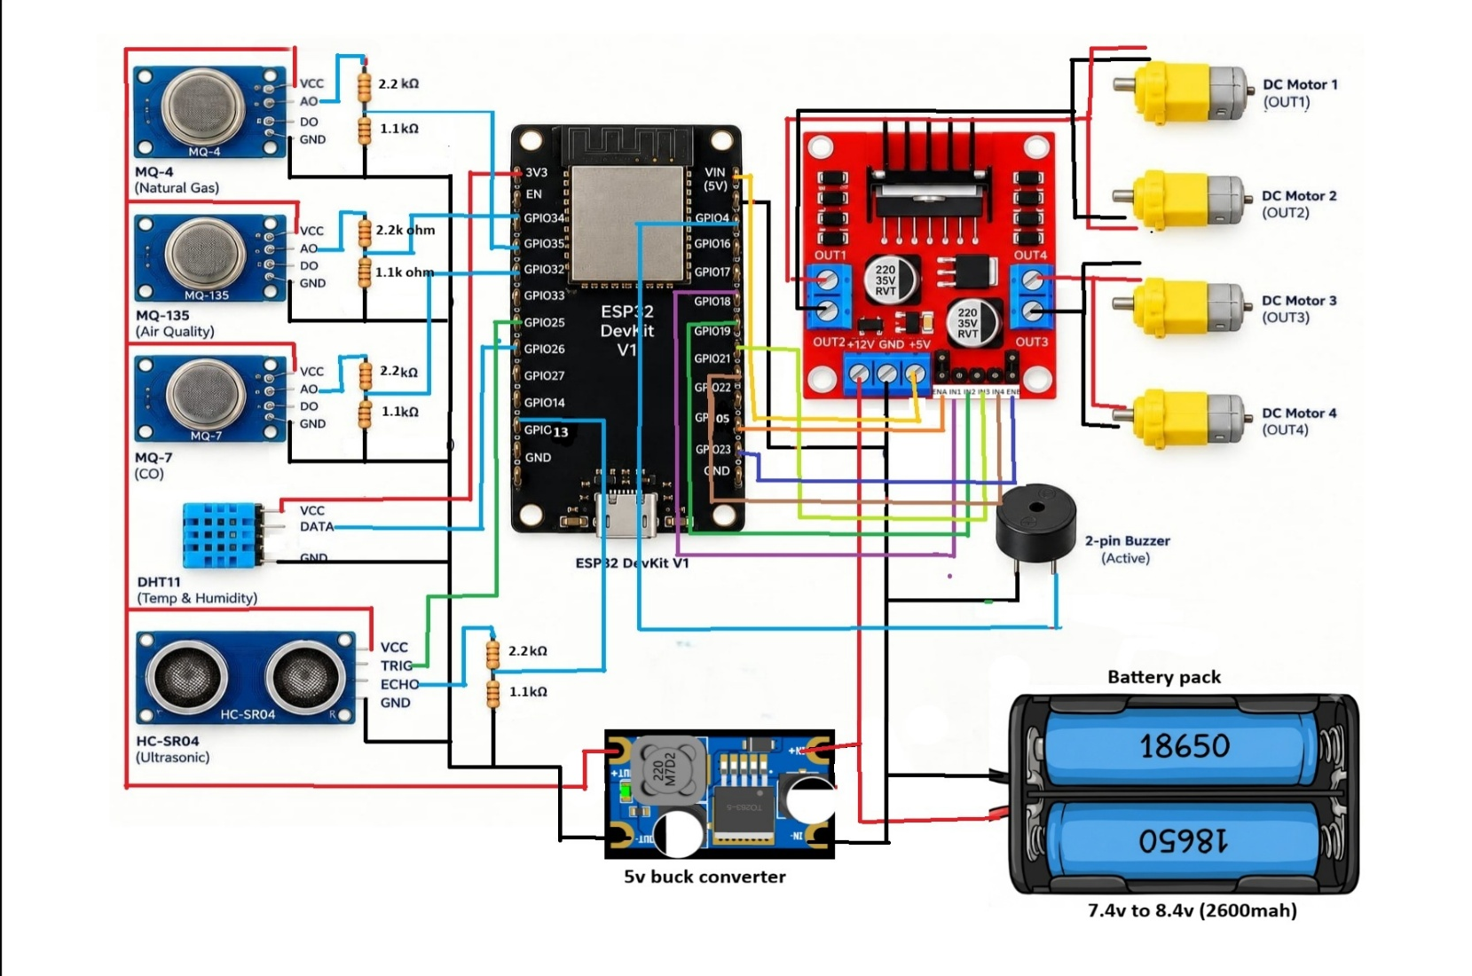

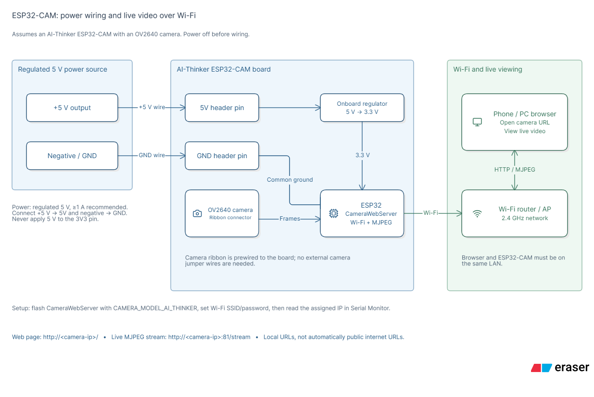

Overall block diagram
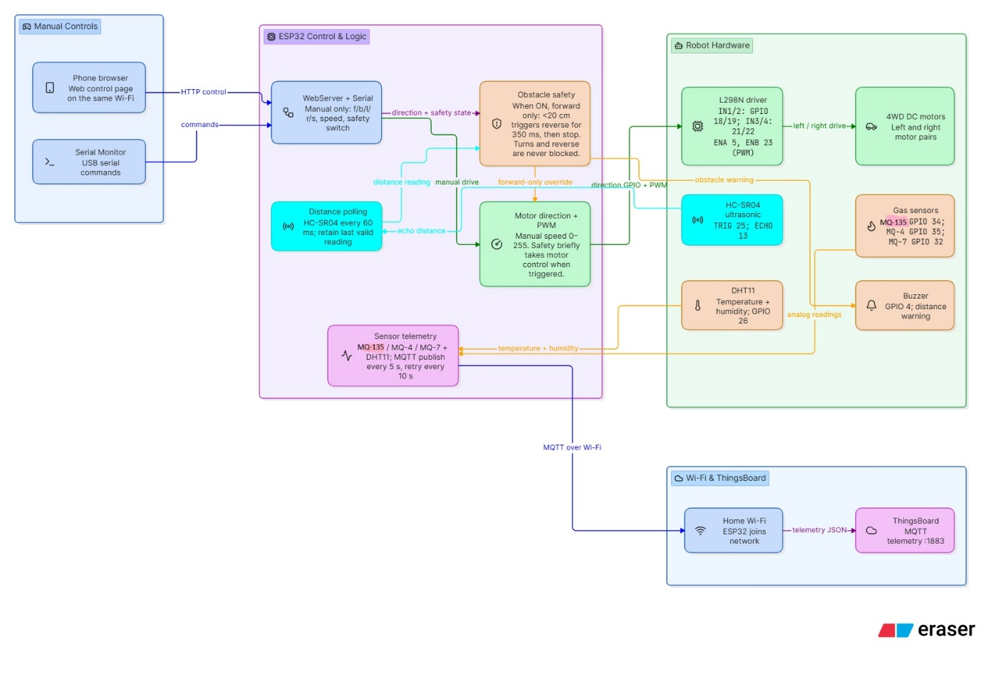

4. Circuit Description
The ESP32 is the centre of the circuit. All sensors, the motor driver and the buzzer connect to it. Update the pin numbers in the table if your wiring is different.
Device | Connection | ESP32 pin
MQ-135 (analog out) | Analog input | GPIO 34
MQ-4 (analog out) | Analog input | GPIO 35
MQ-7 (analog out) | Analog input | GPIO 32
DHT11 (data) | Digital input | GPIO 26
Ultrasonic TRIG / ECHO | Digital out / in | GPIO 25 / 13
Buzzer | Digital output | GPIO 4
L298N IN1 to IN4 | Direction control | GPIO 18, 19, 21, 22
L298N ENA, ENB | Speed (PWM) | GPIO 5, 23

- The three MQ sensors need a 5 V supply and give an analog voltage that changes with gas concentration.
- The DHT11 sends temperature and humidity as a digital signal on one wire.
- The ultrasonic sensor sends a pulse and the ESP32 measures the echo time to find distance.
- The L298N takes direction and speed signals from the ESP32 and powers the four motors from the battery.
- The buzzer is switched on by the ESP32 for obstacle or gas alerts.
- The ESP32 connects to Wi-Fi and sends all readings to ThingsBoard. The ESP32-CAM runs separately on its own supply and streams video.
- All grounds (battery, L298N, ESP32 and sensors) are connected together.

5. Component Details
Each component is explained with its block diagram, working principle, applications, and advantages and disadvantages.

5.1 ESP32 Microcontroller

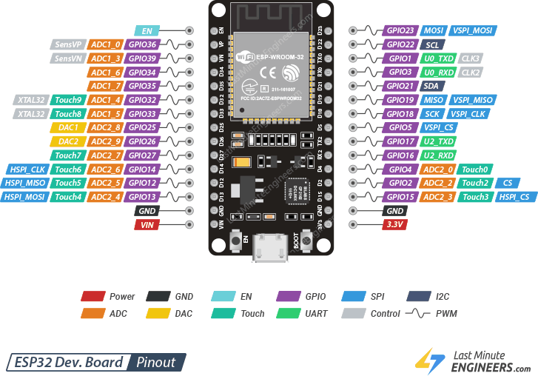
a) Block diagram
Sensors | → | ESP32 | → | Motors / Buzzer / Wi-Fi
b) Working principle
The ESP32 is a low-cost microcontroller with a dual-core processor and built-in Wi-Fi and Bluetooth. It reads analog signals from the gas sensors, digital data from the temperature sensor and distance sensor, then decides what the rover should do. It drives the motors, switches the buzzer, and sends the readings over Wi-Fi to the online dashboard.
c) Applications
- IoT and smart-home devices
- Robotics and automation
- Wireless sensor networks
- Industrial monitoring
d) Advantages and disadvantages
Advantages | Disadvantages
• Built-in Wi-Fi and Bluetooth  • Fast dual-core processor  • Low cost and low power sleep modes  • Many input/output pins | • Analog pins read less accurately at the extremes  • Higher power use than basic Arduino boards while Wi-Fi is on  • Operates at 3.3 V, so some parts need level shifting

5.2 MQ-135 Air Quality Sensor

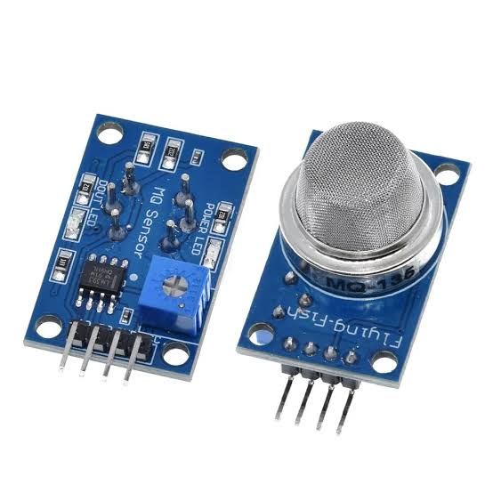
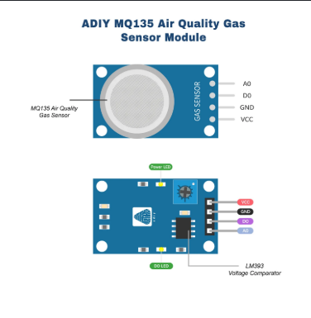

a) Block diagram
Air pollutants | → | MQ-135 (SnO₂ element) | → | Analog voltage | → | ESP32
b) Working principle
The MQ-135 contains a tin dioxide (SnO₂) sensing layer and a small heater. In clean air its resistance is high. When harmful gases such as ammonia, nitrogen oxides, benzene, alcohol, smoke or carbon dioxide are present, the resistance drops. The sensor circuit converts this change into an analog voltage, which the ESP32 reads and compares with a safe limit to judge overall air quality.
c) Applications
- Air quality monitoring
- Indoor and outdoor pollution detection
- Ventilation control
- Mine and tunnel air checks
d) Advantages and disadvantages
Advantages | Disadvantages
• Detects a wide range of harmful gases  • Low cost  • Fast response  • Easy analog output | • Not selective: cannot tell which gas is present  • Needs warm-up and burn-in time  • Readings affected by temperature and humidity  • Gives approximate values, not certified ppm

5.3 MQ-4 Gas Sensor
a) Block diagram
Methane (CH₄) | → | MQ-4 (SnO₂ element) | → | Analog voltage | → | ESP32
b) Working principle
The MQ-4 works like the MQ-135 but is tuned to methane, the natural gas that causes explosions in coal mines. When methane touches the heated sensing layer its resistance falls. This is converted to a voltage that the ESP32 measures to judge how much methane is present.
c) Applications
- Methane detection in mines
- Natural gas / biogas leak detection
- Industrial and household gas alarms
d) Advantages and disadvantages
Advantages | Disadvantages
• Good sensitivity to methane  • Low cost  • Quick response  • Simple analog output | • Also reacts to other gases such as LPG and alcohol  • Needs pre-heating and calibration  • Accuracy changes with temperature and humidity  • Not a certified safety instrument

5.4 MQ-7 Gas Sensor

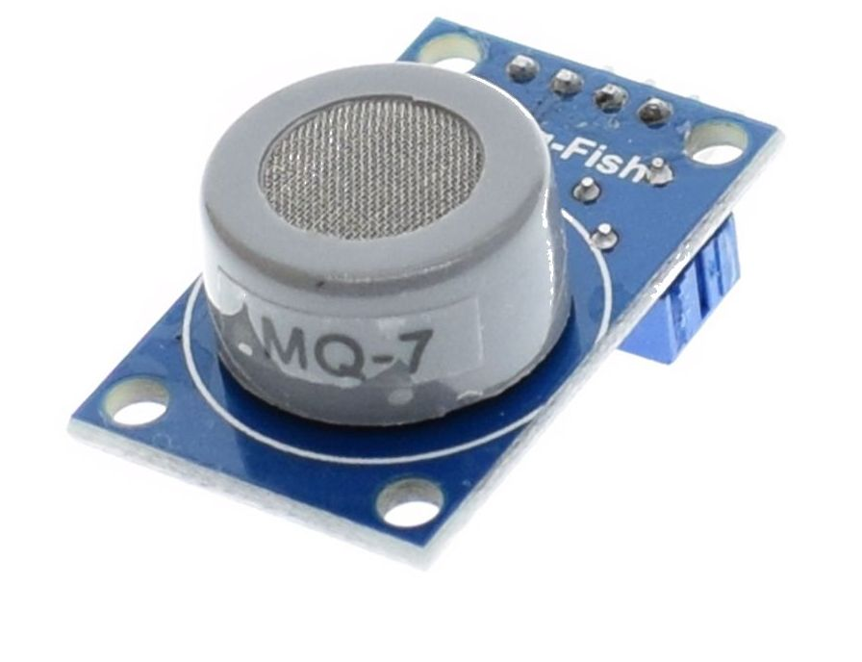
a) Block diagram
Carbon monoxide (CO) | → | MQ-7 (SnO₂ element) | → | Analog voltage | → | ESP32
b) Working principle
The MQ-7 is designed for carbon monoxide, a deadly gas with no colour or smell. Its sensing layer changes resistance when CO is present. The sensor circuit turns this into an analog voltage that the ESP32 reads. A high reading means CO is building up and the buzzer and dashboard alert are triggered.
c) Applications
- Carbon monoxide leak detection
- Mines, tunnels and garages
- Vehicle and boiler exhaust monitoring
- Home CO alarms
d) Advantages and disadvantages
Advantages | Disadvantages
• Sensitive to CO  • Low cost and compact  • Long life  • Easy analog output | • Best accuracy needs a special heating cycle  • Reacts to some other gases  • Needs warm-up  • Approximate readings only

5.5 DHT11 Temperature and Humidity Sensor

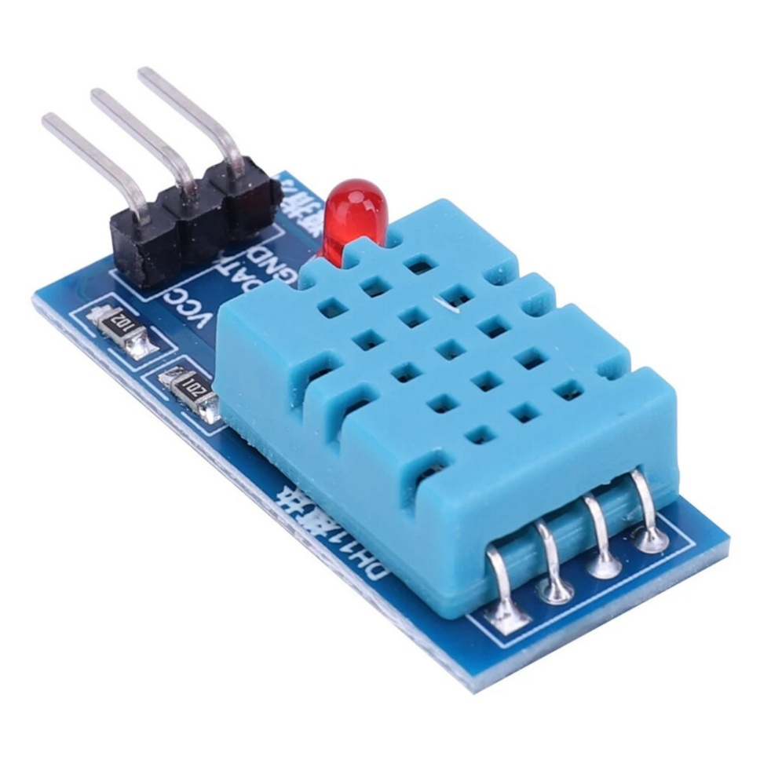
a) Block diagram
Air | → | DHT11 (thermistor + humidity element) | → | Digital signal | → | ESP32
b) Working principle
The DHT11 has a humidity-sensing element and a thermistor. A small chip inside converts both measurements into a digital signal and sends it to the ESP32 on a single data wire. The rover uses it to check whether the mine air is getting too hot or too humid.
c) Applications
- Weather stations
- Home automation and HVAC
- Greenhouses
- Environmental monitoring
d) Advantages and disadvantages
Advantages | Disadvantages
• Very low cost  • Digital output, no calibration needed  • Easy to use  • Low power | • Limited accuracy (about ±2°C and ±5% RH)  • Slow: one reading per second  • Limited temperature range (0 to 50°C)

5.6 Ultrasonic Sensor (HC-SR04)

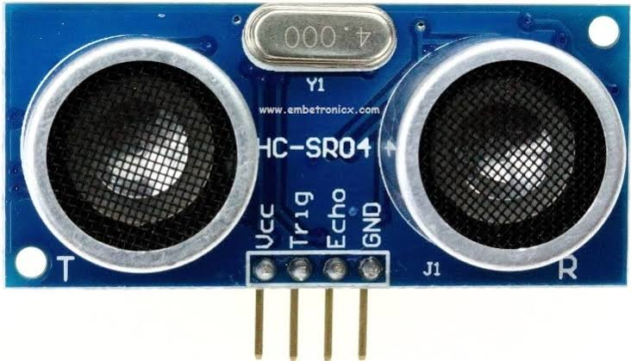
a) Block diagram
ESP32 trigger | → | Ultrasonic pulse sent | → | Echo from obstacle | → | Distance calculated
b) Working principle
The sensor sends out a burst of high-frequency sound that humans cannot hear. The sound bounces off an obstacle and returns as an echo. The ESP32 measures the time taken and calculates distance using: Distance = (Time × Speed of sound) / 2. If the distance is below a set limit, the rover stops, beeps and turns away.
c) Applications
- Obstacle avoidance robots
- Parking assistance
- Level measurement in tanks
- Distance measurement
d) Advantages and disadvantages
Advantages | Disadvantages
• Low cost  • Accurate for short range (2 cm to 4 m)  • Works in darkness  • Easy to interface | • Soft or angled surfaces may not reflect well  • Affected by temperature and noise  • Narrow detection cone

5.7 L298N Motor Driver with 4WD Chassis

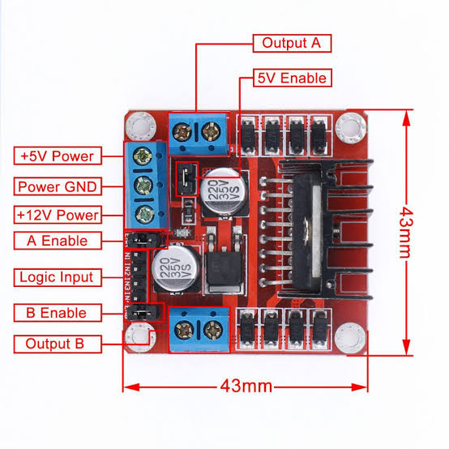
a) Block diagram
ESP32 signals | → | L298N driver | → | DC motors | → | Wheels move
b) Working principle
The ESP32 cannot power motors directly. The L298N is an H-bridge driver that takes low-power signals from the ESP32 and switches the high-current battery supply to the motors. Changing the input signals reverses the motor direction, and PWM signals control the speed. The 4WD chassis carries all parts and gives the rover traction.
c) Applications
- Robotic vehicles
- Automated carts
- Remote-control cars
- Educational robots
d) Advantages and disadvantages
Advantages | Disadvantages
• Controls two motors with speed and direction  • Handles good current for small motors  • Cheap and widely available  • 4WD gives better grip | • Voltage drop makes it less efficient and warm  • Heat sink needed for heavy loads  • 4WD uses more battery power

5.8 ESP32-CAM Module

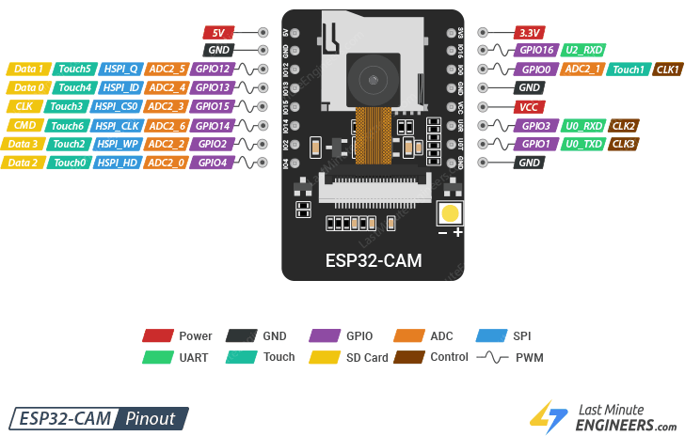
a) Block diagram
Camera lens | → | ESP32-CAM | → | Wi-Fi | → | Dashboard / Browser
b) Working principle
The ESP32-CAM combines an ESP32 chip with a small camera. It captures images, compresses them, and streams them as live video over Wi-Fi. The operator opens the stream in a browser or on the dashboard to see what is ahead of the rover.
c) Applications
- Remote surveillance
- Inspection of unsafe areas
- Smart doorbells
- Robot vision
d) Advantages and disadvantages
Advantages | Disadvantages
• Very low cost  • Wi-Fi streaming built in  • Small size | • Video quality is basic  • Needs a stable 5 V supply  • Limited range and Wi-Fi dependence  • No built-in USB programmer

5.9 Buzzer

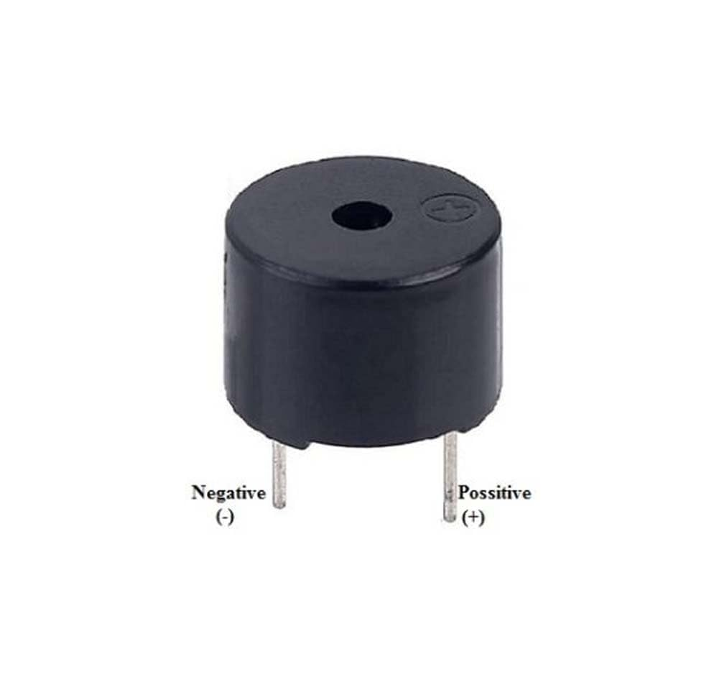
a) Block diagram
ESP32 output | → | Buzzer | → | Loud alert sound
b) Working principle
The buzzer produces sound when it gets a voltage. The ESP32 switches it on when the rover is about to hit a wall or when any gas sensor crosses its limit. Short beeps mean an obstacle, a continuous tone means a gas alert.
c) Applications
- Alarms and alerts
- Timers
- Security systems
- Industrial warnings
d) Advantages and disadvantages
Advantages | Disadvantages
• Very cheap and small  • Loud and attention-grabbing  • Simple to drive | • Only one tone for active buzzers  • Can be missed in noisy places  • Gives no detail about the cause

6. Results
a) Photograph of the hardware
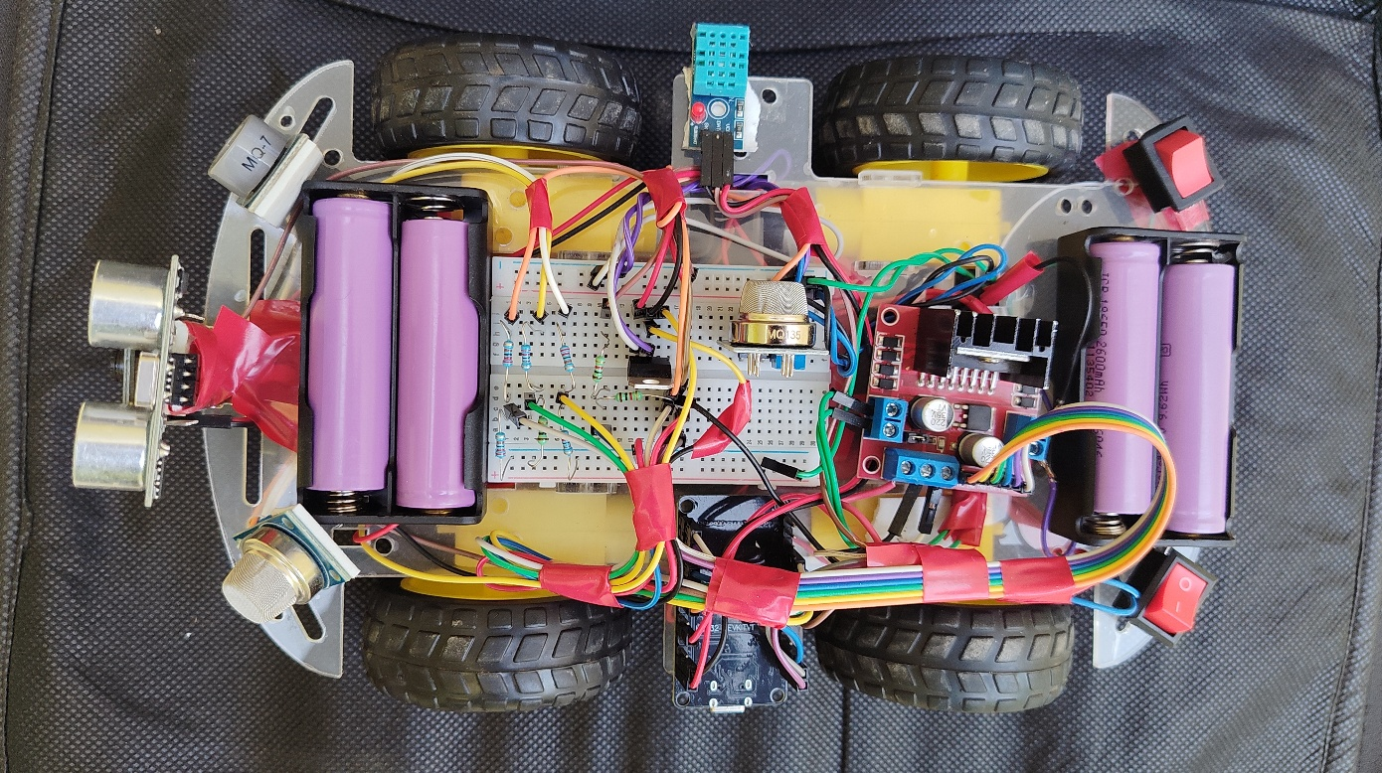

b) Output results: waveforms (graphs)

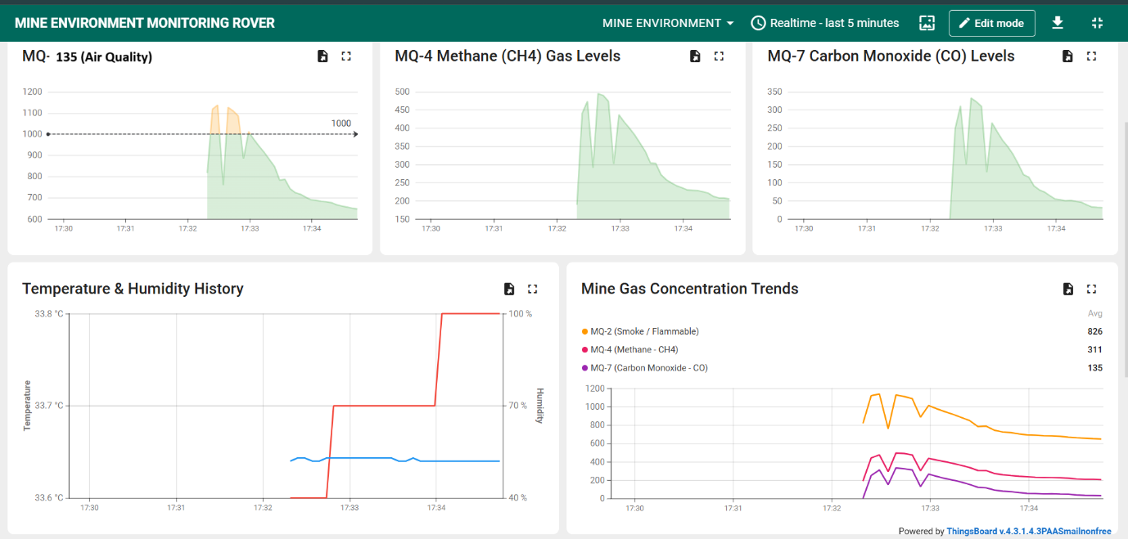
c) Digital output
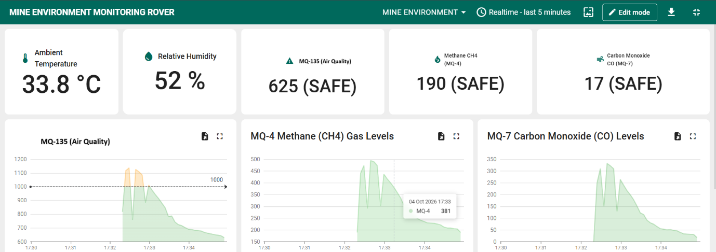
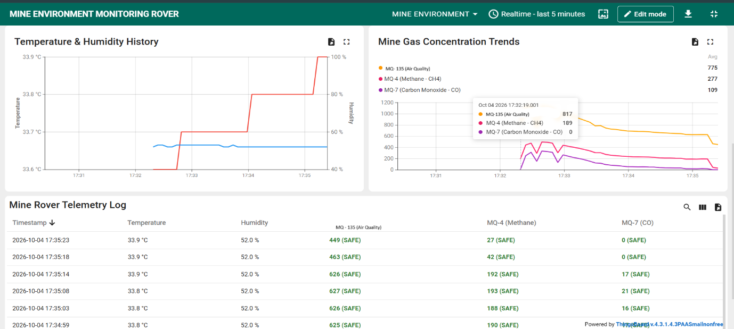

Test | Expected result
Clean air | Low sensor values, no alarm
Gas near sensor | Value rises, buzzer on, dashboard alert
Obstacle ahead | Rover stops, beeps, turns
Temperature / humidity | Values shown on dashboard
Camera | Live video visible

7. Conclusion
The Mine Environment Monitoring Rover successfully detects air-quality gases (smoke, ammonia, CO₂), methane and carbon monoxide, measures temperature and humidity, avoids obstacles, and shows the path ahead through a camera. Readings and alerts are sent over IoT to a ThingsBoard dashboard, so people can monitor dangerous areas from a safe distance. The project shows how low-cost embedded systems can improve safety in mines and similar hazardous places. It can be improved with longer-range communication, more accurate sensors, remote driving and AI-based hazard detection.

